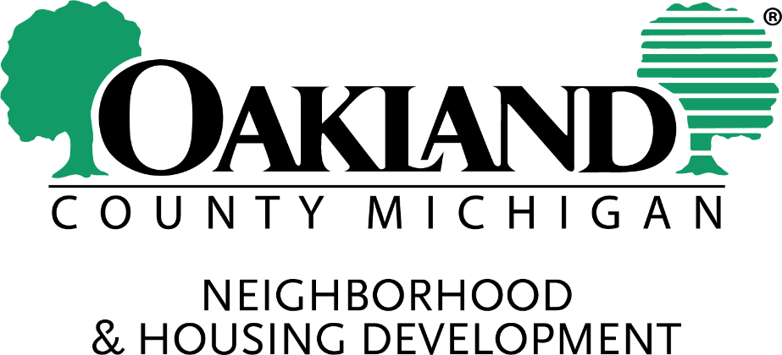

**Notice of Public Comment Period & Public Hearing**

Oakland County DRAFT HOME American Rescue Plan (ARP) Program Funding Priorities

Monday, October 31, 2022

The Oakland County Neighborhood & Housing Development Division is finalizing its plan for use of the HOME American Rescue Plan (ARP) Program funding. The Division is seeking input for how the county will invest the available funds.

**Proposed Amendment to the PY 2021 Annual Action Plan for HOME-ARP Activities and Use of HOME-ARP Funds**

**Activities Allocation**

Administration & Planning $1,000,000

Acquisition & Development of Non-Congregate Shelters $8,396,043

Non-Profit Operating $250,000

Non-Profit Capacity Building $250,000

Supportive Services $500,000

**Total $10,396,043**

The HOME-ARP Proposed Amendment will be available for a 15-day public review and comment period from Monday, October 31, 2022, through and including Tuesday, November 15, 2022

Public Comment will be accepted via mail, drop off, or email to: [nhd@oakgov.com](mailto:nhd@oakgov.com) (please add “Public Comment” in the subject line). If mailing or dropping off, please use: *Oakland County Neighborhood & Housing Development, 250 Elizabeth Lake Road, Suite 1900, Pontiac, MI 48341-0414.*

***NOTICE OF PUBLIC HEARING***

Concurrently, notice is hereby given that the Citizens’ Advisory Council will host a **Public Hearing** on the county’s HOME-ARP proposed amendment on Thursday, November 10, 2022, at 10:00 a.m. for the purpose of hearing public comments. The event is **in person** in Committee Room A at the Board of Commissioners building, 1200 N. Telegraph Rd., Pontiac, MI 48341.

There will not be a virtual option; however, if a member of the public would like their comments to be on record for the proceedings and are unable to attend, they may mail, drop off, or email their comments to be read into the proceedings by ***close of business on Wednesday, November 9, 2022***. The Division is open until 5:00 p.m.

If you require special accommodations because of a disability, please contact Oakland County Neighborhood & Housing Development at 248 858-0493 or TDD Hearing Impaired (248) 858-5511 at least three (3) business days in advance of the meeting.

Public comments will be accepted via mail, drop off, or email to: [nhd@oakgov.com](mailto:nhd@oakgov.com) (please add “Public Comment” in the subject line). If mailing or dropping off, please use: *Oakland County Neighborhood & Housing Development, 250 Elizabeth Lake Road, Suite 1900, Pontiac, MI 48341-0414.*